Community Asset Register Briefing Note

The Community Asset Register (CAR) is a database of Community assets. These assets are operated by volunteers rather than paid members of the Scottish Fire and Rescue Service (SFRS), and can be made available to assist the SFRS, or other partners, in bringing incidents to a successful conclusion.

The CAR gives members of the public and other voluntary groups the opportunity to offer help to their communities generally under the guidance of the Emergency Services (Category 1 Responders), under the umbrella of Scottish Resilience.

The CAR is an electronic database displayed on a map. It is possible to search and filter the data using a number of parameters in order to identify assets which may be potentially useful at an incident.

The database is administered by the SFRS but is made available to authorised partners.

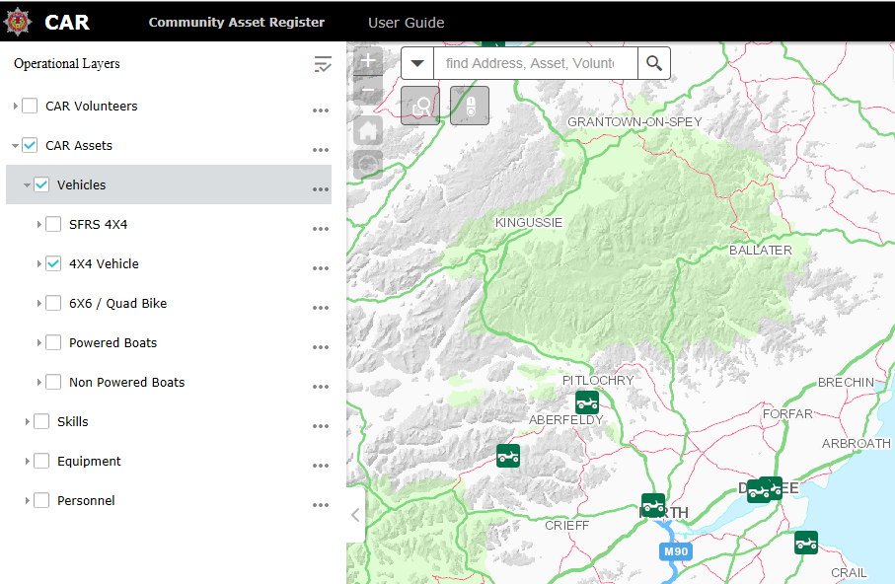

The registration of Community Volunteers on the CAR is a 5 stage process;

- Initial information gathering
All community volunteers or volunteer groups will be required to complete a questionnaire which will serve to collect the relevant details which will be required for the CAR. Assets will be grouped under one of the following headings;
- Vehicles
- Skills
- Equipment
- Personnel.
- Analysis of Information
The information supplied will be analysed and each community volunteer, or volunteer group will be categorised by asset and team type. Eg. Water, Rope, Medical etc. Qualifications supplied will be reviewed, and the location of the volunteers plotted and verified. If a volunteers qualifications, experience and reliability are not sufficient then they will be included as a less onerous task type, or not be included on the register. The volunteer should then be informed accordingly.

- Command Induction Course
Each individual volunteer will be required to complete a short programme of learning in order to ensure that they are prepared to operate safely at incidents. This will be carried out online and verified by answering a series of questions. This process will be hosted on the Scottish Resilience Development Service (ScoRDS) website. Details for how to register and complete this training are sent to the volunteers on receipt of an application questionnaire. (Guidance below).

- Minute of Agreement
Individuals, or groups of individuals who are not in the form of a well constituted organisation which is set up for emergency response, will be required to approve a Minute of Agreement. This agreement is to make clear their responsibilities and offer guidance on mobilisation. This should be understood and signed by volunteers falling into this category. This document should then be returned to SFRS for authorisation and filing.

- Generation of the CAR record
Once authorised, the record will then be generated within the CAR database and the volunteer will be available through the system. All volunteers and assets will be reviewed on an annual basis. This will be carried out by CCOs using a rolling process throughout the year.

Activation of the CAR and Deployment of Community Volunteers

The first stage in an SFRS deployment of CAR assets is to identify that there is a valid need for it. The types of incidents where the CAR is most suitable to be used are:
- Incidents where support from community assets will enhance the multi-agency response.
Community Volunteers from the CAR might be able to support our deployment and to enhance and improve our response to a multi-agency incident. This may also give the community a greater sense of ownership of the incident and its resolution.
- Incidents where a community asset may be able to make an intervention in a shorter timeframe than a similar SFRS asset.
SFRS assets may from time to time take a significant time to reach an incident, particularly in remote rural areas. Community assets may be located so that they are able to reach the incident scene before SFRS assets. In these cases, if a suitable community asset has been registered on the CAR, then it may be appropriate to request the deployment of that asset, once the SFRS resource has been mobilised, in an attempt to save life or reduce distress.
- Incidents where SFRS does not possess the required skills or equipment.
Some incidents may benefit from the application of skills or equipment which the SFRS does not possess. This might include assets as diverse as sandbags, earth moving equipment or even provision of widespread welfare relief to staff or the public.
- Incidents where community assets may be located where they are able to reach an incident scene before the arrival of any SFRS resources. Where this is the case it may be appropriate to request the deployment of a registered community asset to support the SFRS mobilisation, whilst informing the community asset they will arrive first.
In order to determine if the CAR is a suitable solution, data collection must be accurate, up to date and a good knowledge of local capability is required.

Links and Documents:

Below is the link to the latest version of the CAR.

http://car/

The embedded document below contains the guidelines issued to Community Volunteers on how to access and complete the online Command Induction Course.

