The Community Asset Register | 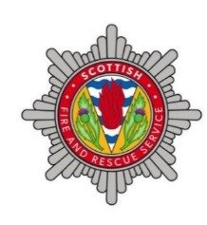 | 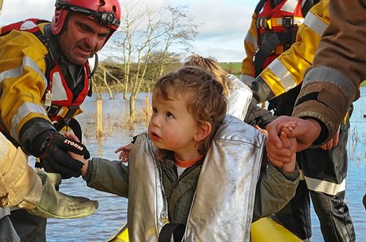
What is the Community Asset Register?

The Community Asset Register is a database of volunteers willing to protect and support their communities in an emergency. Volunteers work alongside the Scottish Fire and Rescue Service and other emergency responders, to bring incidents to a successful conclusion.

Volunteer assets could include: 4x4 vehicles, boats or generators, or specialised skills such as rope or water rescue . We encourage individuals or groups with skills or equipment to consider joining.

The Scottish Fire and Rescue Service may ask a volunteer to attend an incident when the volunteer:
- could support or enhance the multi-agency response
- could intervene more quickly than a similar Scottish Fire and Rescue Service asset
- has equipment or skills the Scottish Fire and Rescue Service does not possess.

The Scottish Fire and Rescue Service manage the database, but it can be accessed by other emergency responders.

How do I join the Community Asset Register?

Email sfrs.communityassetregister@firescotland.gov.uk. Volunteers will be asked to:

- complete a questionnaire detailing their skills and equipment
- provide evidence of their qualifications (where applicable)
- complete a 30 minute online Community Asset Register command induction course
- sign a minute of agreement with the Scottish Fire and Rescue Service which details expectations and liability coverage.

How often will a Community Asset Register volunteer be called upon?

The number of call outs will depend on the:
- volunteer’s equipment, skills and location
- number and type of incidents in an area
- Scottish Fire and Rescue Service’s capacity at an incident; volunteers won’t be called, if they’re not needed.

Even when called, volunteers do not have to attend. Volunteers decide if they are able to.

For more information

Go to: www.firescotland.gov.uk or email: sfrs.communityassetregister@firescotland.gov.uk

